**LAB # 02**

**Task 01:**

Write a program that takes input as radius then calculate area of circle. (Hint: A= πr²).

**Code:**

#include<iostream>

using namespace std;

int main(){

    float r = 0.00, a = 0.00, pi = 3.14;

    cout << "Enter radius of a circle: ";

    cin >> r;

    a = pi*(r*r);

    cout << "Area of this circle with radius \'"<<r<<"\' is: "<<a<<endl;

}

**Output:**

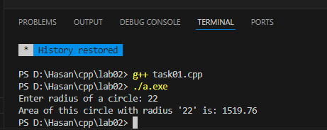

**Task 02:**

Write a C++ program that reads a number in inches and converts it to meters. Note: One inch is 0.0254 meter.

**Code:**

#include<iostream>

using namespace std;

int main(){

    float value_inch = 0.00, value_meter = 0.00;

    cout << "Enter number in inches: ";

    cin >> value_inch;

    value_meter = value_inch*0.0254;

    cout << "Value in meters is: "<<value_meter<<endl;

}

**Output:**

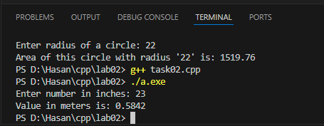

**Task 03:**

Write a C++ program that prompt input roll number, student name and marks of three subjects:

1. Computer Programming = CP
2. Object Oriented Programming= OOP
3. Data Structures & Algorithms= DSA

Calculate total marks, percentage and division of student.

Marks percentage = marks obtained / total * 100

**Code:**

#include<iostream>

#include<string>

using namespace std;

int main(){

    string name;

    int rn = 0; // rn = roll number

    float cp = 0.00, oop = 0.00, dsa = 0.00, per = 0.00;

    cout << "Enter your name: ";

    getline(cin,name);

    cout << "Enter your roll number: ";

    cin >> rn;

    cout << "Enter your marks in Computer Programming CP: ";

    cin >> cp;

    cout << "Enter your marks in Object Oriented Programming OOP: ";

    cin >> oop;

    cout << "Enter your marks in Data Structures and Algorithms DSA: ";

    cin >> dsa;

    per = ((cp+oop+dsa)/(300))*100;

    cout << "Your percentage is: "<<per<<endl;

}

**Ouput:**

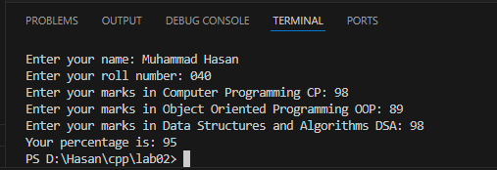

**Task 04:**

Write a program that reads a temperature in degrees Celsius and prints out the corresponding temperature in degrees Fahrenheit (F = (C * 9 / 5) + 32).

**Code:**

#include<iostream>

using namespace std;

int main(){

    float temp_cel = 0.00, temp_fer = 0.00;

    cout << "Enter temperature in Celcius: ";

    cin >> temp_cel;

    temp_fer = ((temp_cel*9/5) + 32);

    cout << "Temperature in Fahrenheit is: "<<temp_fer<<endl;

}

**Output:**

